

School of Engineering and Computing
MSc Cyber Security
Interim Report

Project Title:
Design and Evaluation of a Secure Web-Based Access Control and Tamper-Evident Audit Logging Framework for Simulated Electronic Health Records
by
Name:
Ruth Sara Shajan
Date of submission:
02nd July 2026
Supervisor: Raman Singh
Moderator: Ravi Koirala

- INTRODUCTION
Electronic Health Record (EHR) systems are now the backbone of how healthcare information is stored, shared and reviewed. They contain an individual’s personal details, diagnoses, medications, allergies, clinical notes, appointments and their treatment history. This makes them useful for care delivery, but it is also a high-risk target if access is not controlled properly or activity is not traced after an incident.
A secure EHR system should not treat every user in the same way. A patient should only see their own record while doctors, nurses, GPs and administrators might need different levels of access depending on their responsibilities. If these permissions are too broad, sensitive records may be exposed. If they are not checked on the server side, users may be able to bypass the intended restrictions.
Audit logging is also important, it provides accountability. A good audit trail should contain actions like login attempts, patient record views, denied access attempts, permission changes and audit-log checks. A normal audit log can lose its value when an old entry can be changed or deleted without detection. In this case, the log can show that an event has happened and it cannot provide reliable proof that the log history has not been changed.
This project addresses this issue by developing a small simulated EHR web application using fake patient data. The prototype will integrate role-based access control with audit logging so that different users such as doctors, patients, nurses, GPs and administrators can be tested in a controlled environment. Supporting workflows such as GP registration or appointment requests may be included only when they help create realistic permission and audit log scenarios.
The main security feature is a tamper-evident audit log through hash chaining. This is not intended to be a full blockchain system or a live healthcare platform which is connected to real NHS services. It is a practical web-based prototype which uses blockchain-inspired ideas to check if old audit entries have been changed, deleted or reordered. This allows the project to assess access control enforcement and audit log integrity in a straightforward and manageable manner.

  - RESEARCH QUESTION
To what extent can a secure web-based access-control prototype enforce role-based permissions and maintain a tamper-evident audit history for simulated Electronic Health Records (EHR)?

  - AIM OF THE PROJECT
The aim of this project is to develop, implement and evaluate a secure web-based prototype for managing simulated Electronic Health Records. The prototype will use fake patient data and will focus on two key security issues: controlling who can access patient information and keeping an audit history of important actions.
To be more specific, this project aims to show whether a small Flask and SQLite based system can enforce role-based permissions for users such as patients, doctors, nurses, GPs and administrators. It also aims to assess if a hash-chained audit log can make unauthorized changes to old audit entries detectable, so that the audit history is more trustworthy than a normal editable log.

  - OBJECTIVES OF THE PROJECT
- Review of academic and technical literature on EHR security, role-based access control, audit logging and tamper-evident logs.
- Define the system requirements, user roles, access rules and audit-log events for a simulated EHR prototype.
- Design a Flask and SQLite based web application using fake patient data.
- Implement secure login, password hashing, session handling and server-side permission checks.
- Implement audit logging for important actions such as login attempts, record access, denied access, permission changes, GP requests, appointment requests and audit checks.
- Implement a hash-chained audit log using SHA-256 to detect tampering with old audit entries.
- Tests on whether authorized users can perform allowed actions and unauthorized users are denied.
- Test whether audit log tampering can be detected through chain verification.

  - PROPOSED SCOPE
The proposed scope is to build a small simulated EHR prototype. It is not intended to be the complete hospital system. The project will attempt to control access to fake patient records and create an audit history which can reveal later tampering.
The main users in this scope are patient, doctor, nurse, GP and admin. In this prototype, the GP is treated as a clinical user who can access records for patients which can either be registered or assigned to them, and the doctors and nurses can access records related to their care responsibilities. Patients will only be able to view their own information and make simple requests.
The scope of this prototype includes:
- Secure login, password hashing and session handling
- Fake patient records stored in SQLite.
- Server-side role-based access control checks.
- Audit logging for login attempts, record viewing, denied access, permission changes, GP requests, appointment requests, and audit-log checks.
- Hash-chained audit-log entries that can be verified to detect changes to older logs.
- Test scenarios to compare authorized access, denied access and tampered audit logs.
The GP registration and appointment request features will be kept simple. They are included only because they provide useful examples of permission changes and audit log events. For example, if a patient requests a GP and an admin approves it, the system can test whether the GP gets access correctly and whether that change is recorded in the audit log.
This project will not be using real patient data, connecting to real NHS or hospital systems, implementing prescriptions, billing, messaging, full appointment booking, or a full blockchain platform. These areas are outside of the scope as the project is mainly about access control and tamper-evident audit logging.

- LITERATURE REVIEW
  - ELECTRONIC HEALTH RECORD SECURITY
Electronic Health Record systems store sensitive information about diagnosis, medications, appointments, treatment history, and clinical notes. The literature therefore treats EHR security as more than a normal web application security issue. It has to keep confidentiality, integrity, availability, accountability and patient trust intact.
Anderson (1996) is useful because it explains that clinical information systems need security policies that are specific to healthcare work and not just generic computer accounts. The paper mentions that patient information may need to be accessed by different people involved in care, but access must still be governed by clear rules. This is the basis of the decision to model patients, doctors, nurses, GPs and administrators as distinct role with different access needs for this project.
A limitation of Anderson’s work is that it is primarily a policy model and not a small web implementation. It helps define what should be controlled but does not make a direct display of how to create a Flask prototype or how to test tamper-evident logs. In this project, this policy idea is used in a more practical way by turning role and assignment checks in a simple way in the protype.
Shojaei, Vlahu-Gjorgievska, and Chow (2024) recently conducted a systematic review of security and privacy in health information systems. Their work shows that health system security usually requires several controls working together, such as access control, secure storage, data sharing protection, authentication, and privacy management. This aligns with the project’s entire focus on login security, role-based access control, and audit logging, rather than being limited to one security aspect only.
The same review shows a limitation as well which is important for this project: many healthcare security solutions are complex and may involve large architecture, multiple organisations, or advanced technologies. This project will not try to make a complete healthcare platform. Instead, it will create a focused simulated system where the key security behaviours can be tested clearly.

  - ACCESS CONTROL AND RBAC IN HEALTHCARE
Access control is fundamental to EHR security because different users should not have the same level of access. A patient should be able to see just their own records, and clinical users should see only records related to their care responsibilities. Admin users can do their own accounts and assignments but should not be required to have unrestricted clinical access unless the prototype explicitly allows it.
Ferraiolo and Kuhn (1992) and Sandhu et al. (1996) provide the foundation for Role-Based Access Control. RBAC is useful because permissions are attached to roles, and users are assigned to the roles. This makes it easier to set up and manage rather than have permissions for each user on an individual basis. RBAC supports the first level of access control: patient, doctor, nurse, GP, and admin in this project.
But RBAC can be too broad for healthcare. If every doctor role can view every patient record, then the system can still expose unnecessary information. That is why the prototype needs to look at not only the role of the user but also the user's relationship to the patient record. For example, a doctor, nurse, or GP should only access a patient if they are assigned to that patient or if the patient is registered with that GP.
Blobel (2004) strengthens this point by highlighting that EHR authorisation cannot simply be organised at the individual user level in wider health networks. The paper distinguishes between structural roles and functional roles and shows how access to healthcare is not just organisational but functional as well. The full model is too advanced for this project, but the idea can be simplified into role checks and patient assignment checks.
Gajanayake, Iannella, and Sahama (2012) also show that privacy-oriented access control for EHRs may need to consider consent, purpose, and patient preferences. This is outside the scope of the prototype, but it supports the simple GP registration/request workflow. The workflow provides the project with a realistic way to test a change in patient-clinician relationship without building a complete consent-management system.

  - AUDIT LOGGING IN EHR SYSTEMS
Audit logs show who took an action, what they did, when it happened, what record was affected, and whether the action succeeded or was denied. In healthcare, audit logs are important because inappropriate access to a patient record might not be visible immediately, so the system needs evidence that can be reviewed later. King and Williams (2012) insist that EHR logging and auditing are needed for accountability and trust. And they also point to a reality: once health information has been wrongfully viewed, the privacy harm cannot be reversed. This supports the need to log both successful and denied access attempts, not only errors or system failures.
Rostad and Edsberg (2006) are particularly relevant since they studied healthcare access logs and found that audit trails can be used to identify access control requirements and investigate unusual access. Their work also illustrates a limitation of audit logs: if they are too large, too vague, or not properly structured, they can be hard to understand. So, this project needs structured audit fields, not just text messages.
HL7 International (2023) describes AuditEvent resources for recording events connected to privacy, security, operations, and system activity. NIST guidance on computer security log management also substantiates the need to record, protect, analyse, and store log records (Kent and Souppaya, 2006). Collectively, they support the intended audit-log fields, including user, role, action, target patient or object, outcome, timestamp, and details.
This literature also impacts the test design. The project should not only test whether pages load properly. It should assess whether key events form audit entries: login success, login failure, record view, denied record access, permission or assignment change, GP request approval, appointment request, audit-log verification, and attempted tampering.

  - TAMPER-EVIDENT AUDIT LOGGING
A normal database audit log may show what happened, but it may not prove that the log history is unchanged. If a malicious user or attacker can edit or delete an old audit entry, the system may lose the evidence needed to investigate unauthorised access.
Schneier and Kelsey (1999) handle this problem in their work on secure audit logs for computer forensics. Their work supports the idea that audit logs should be designed so that later modification becomes detectable. This is important for the project because the main security feature is not only recording events but checking whether old events have been changed.
Waters et al. (2004) also discuss secure audit logging and advocate for the use of hash-chain based integrity protection. A hash chain links each log entry to the previous one. If an old entry is edited, deleted, or reordered, the later hashes should no longer match. This directly supports the proposed design using previous_hash and entry_hash fields in the SQLite audit log table.
The only limitation of hash chaining is that it is tamper-evident, not tamper-proof. It may show that a log chain has been changed, but it does not prevent an attacker from deleting the whole database, changing the verification code, or compromising the application before logs are written. Encryption, remote storage, trusted timestamps, or key evolution are other systems that are possible for a more advanced system like the MSc prototype.
For this purpose, the practical implementation will be very focused. Each important audit event will be written with the hash of the previous entry and the new hash calculated from the current entry content. The evaluation will manually change an old audit entry in SQLite and then run a verification function to check if the broken chain is detected.

  - LITERATURE GAP AND SCOPE OF PROJECT
The literature review is being used to define the final scope of the project. The process is to review the existing work and identify what is useful, appreciate the limitations and then build a prototype that is realistic for the available time.
EHR security needs more than a login page. RBAC provides a manageable framework for defining user permissions, but healthcare access also needs patient-care relationships and assignment checks. Audit standards and healthcare logging papers show that audit records are structured and useful for later investigation. Secure logging research shows that regular audit logs are weak if old entries can be silently changed.
The gap in this project is not that RBAC, audit logging, or hash chaining are new ideas. Instead, the gap is one of integration and evaluation in a small simulated EHR context. Many existing approaches are policy-based or standards-based or are designed for big systems. This project will bring all these ideas together in a manageable prototype and test if the security behaviour is what we expect to see.
The proposed implementation is therefore also influenced by the literature: healthcare-specific access rules (Anderson, 1996; Blobel, 2004), RBAC structure (Ferraiolo and Kuhn, 1992; Sandhu et al., 1996), patient-clinician relationships such as GP registration (Gajanayake, Iannella and Sahama, 2012), audit events (King and Williams, 2012; Rostad and Edsberg, 2006; International Organization for Standardization, 2021; HL7 International, 2023), and hash-chain mechanism to identify tampering (Schneier and Kelsey, 1999; Waters et al., 2004).
The evaluation will focus on three measurable questions: whether authorised actions are allowed, whether unauthorised actions are denied and logged, and how changes to older audit log entries are detected by chain verification. This keeps the project focused on the research question rather than becoming a generic healthcare booking system.

- RESEARCH METHODOLOGY
  - RESEARCH APPROACH
This project will be a development-based design and evaluation process. The project will first review relevant literature and design requirements for the proposed system. Then, a web-based prototype will be developed and tested against the security scenarios.
This is a good approach because the project has practical technical output and a tangible academic goal. The evaluation will focus on access-control enforcement, audit-log creation and tamper-evident audit-chain verification.
The research process follows the supervisor's recommended order: complete the literature review, analyse existing systems and ideas from other researchers, identify a gap or weakness, define the project scope from that gap, and then complete the research design and methodology.
The literature review will not be treated as a separate writing task. It will be used to decide what the prototype should realistically achieve, what should remain outside the scope, and which features are justified because they support access-control or audit-log testing.
  - PROPOSED PROTOTYPE
The proposed system is a simulated EHR web application using fake patient data. It will run locally in a browser and will not be connected to any real healthcare system.
- Secure login and logout,
- User roles for patient, doctor, nurse, GP and admin;
- Fake patient record storage,
- Role-based access control and server-side permission checks,
- Simple GP registration or assignment request workflow,
- Simple appointment request workflow,
- Audit logging of important actions (hash-chained entries and integrity verification).
  - TOOLS AND TECHNOLOGIES USED
Area | Planned tool to be used
Programming Language | Python
Web Framework | Flask
Database | SQLite
Frontend | HTML and CSS
Password Storage | Werkzeug password hashing or equivalent Flask-compatible hashing
Audit log Hashing | SHA-256
Development Environment | Local Machine
Testing Method | Manual test cases and possible Python unit tests
Data | Fake/simulated patient data only
SQLite is relevant at this stage as the system is a prototype and does not need a massive database server. Flask is suitable because it is lightweight and can be used for a small web application.

  - DESIGN OVERVIEW
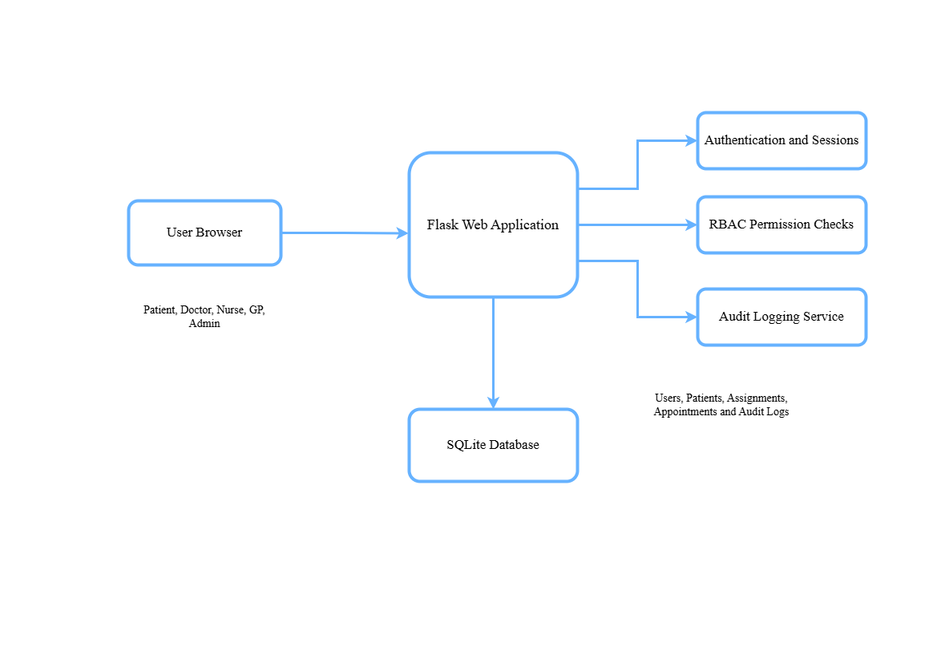The design of the prototype is illustrated in the following diagrams at the interim stage as it will help to clarify the architecture, access-control process, and tamper-evident audit-log design before implementation.
Figure 1: Proposed System Architecture

Design Area | Planned Design
System Architecture | Browser-based user interface, Flask backend, SQLite database, authentication/session handling, RBAC checks, audit logging and audit chain verification.
Database | Tables for users, patients, patient assignments, GP requests, appointments, clinical notes, and audit logs.
Access Control | Every protected route will check login status, role and assignment before returning data or performing actions.
Audit Logging | Important actions will create structured audit entries with user, role, action, target, outcome, timestamp, details, previous_hash and entry_hash.
Tamper detection | Audit entries will be verified in order by recalculating hashes and checking previous_hash links.

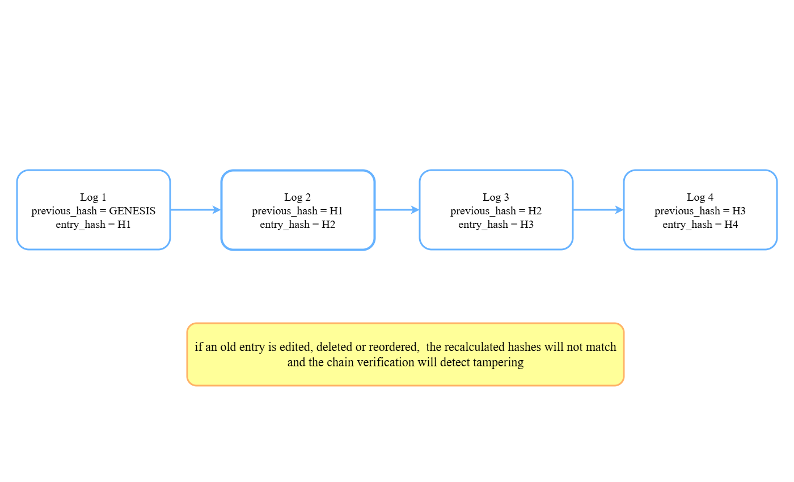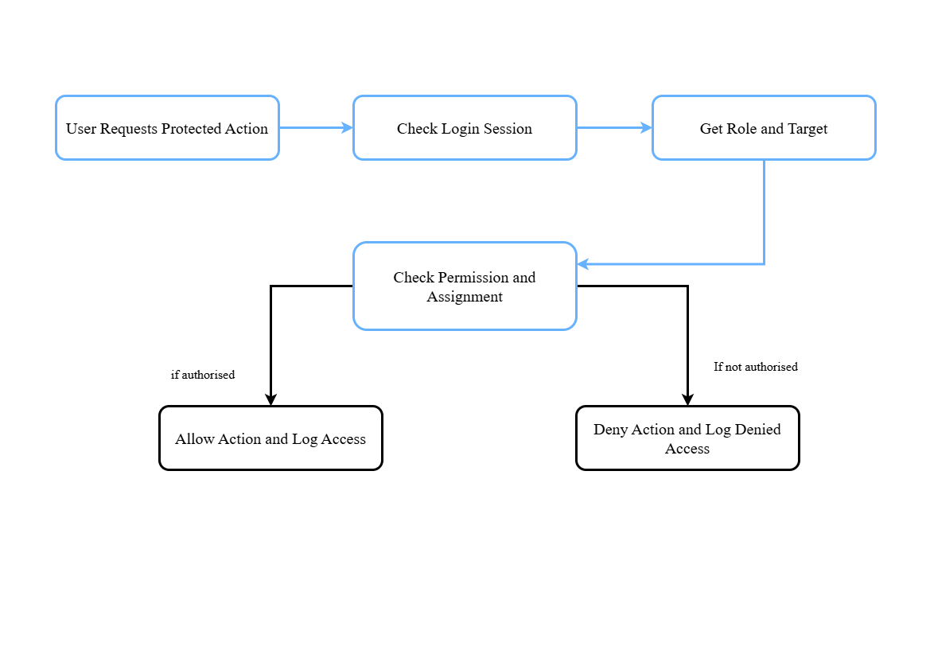
Figure 3: Tamper-evident Audit log hash chain
Figure 2: Access Control flow in Server-side
  - PLANNED EVALUATION
The evaluation will be scenario-based. The goal is to test whether the implemented prototype behaves according to the access-control and audit-log design instead of testing it as a production healthcare system.
Authentication testing will check whether successful login, failed login, logout behaviour, and failed attempts are recorded in the audit log. Access-control testing will check if users can only access records permitted by their role and assignment. This will include direct URL-changing attempts to confirm that permissions are enforced on the server side.
Workflow testing will check the supporting GP and appointment features where they are included. For example, a patient should be able to request GP registration, an admin should be able to approve the request, and the assigned GP should then be able to access the relevant patient record. These workflow tests are included because they create useful permission-change and audit-log scenarios.
Audit-log testing will check whether important actions create audit records with the correct user, role, action, target, outcome, and timestamp. Tamper-evidence testing will then manually change or delete an older audit entry in SQLite and run the chain verification process to check whether the system detects the broken hash chain.
The results will be recorded using test evidence such as expected result, actual result, pass/fail status, notes, and screenshots were useful. This will allow the final report to discuss how well the prototype enforces permissions and detects audit-log tampering.

  - ETHICAL AND DATA CONSIDERATIONS
The project will use fake patient data only. No real patient information will be collected, stored, or processed. The prototype will be developed and tested locally. The purpose is to simulate security scenarios, not to provide real healthcare services.

- PLAN FOR COMPLETION
The plan for completion is the one discussed with the supervisor. In the interim phase, the focus is to complete the introduction, summary literature review, research methodology, diagrams, and project timeline. The implementation will then follow from the literature-informed scope rather than being built as a generic healthcare web application.
The next step is to conduct a full literature review in EHR security, role-based access control, audit logging, and tamper-evident logging to confirm the final scope of the project, identify the gap that needs to be filled, and identify what should be presented in the prototype. The goal is to build a small simulated EHR system which can enforce role-based permissions and detect changes to old audit logs through hash-chain verification.
The planned order of work is shown in Figure 4 as a 15-week weekly Gantt-style chart. The early weeks are the topic selection, specification, scope, literature review, and interim report. The following weeks are system design, Flask development, role-based access control, audit logging, hash-chain implementation, web security, testing, analysis, and final report completion.
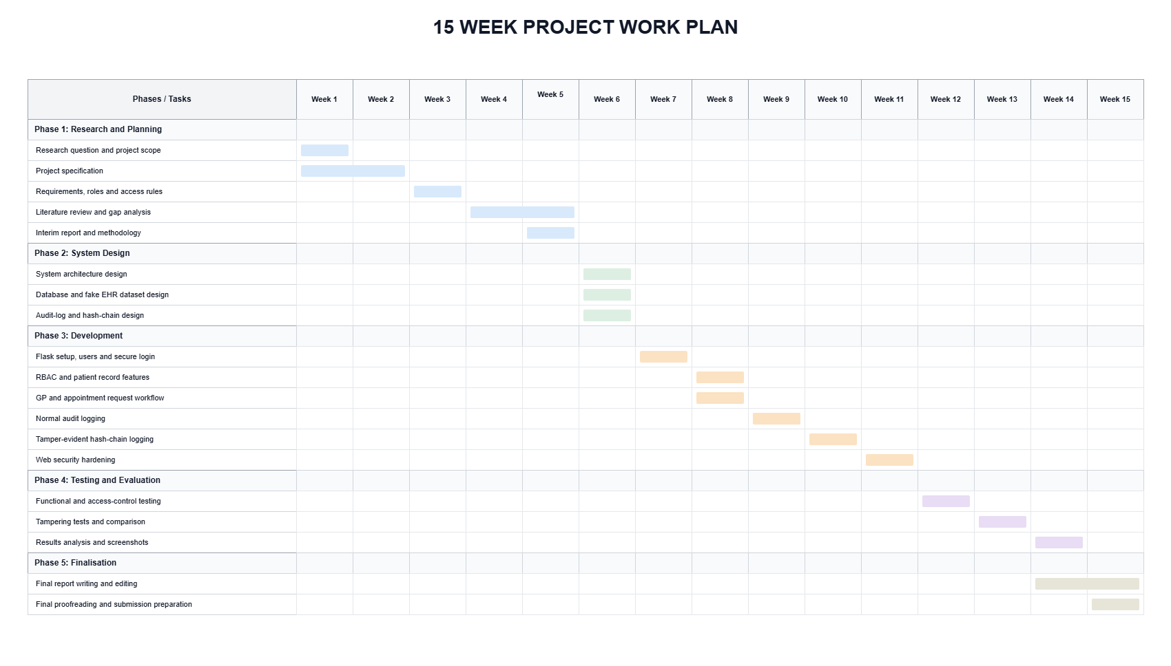
Figure 4: 15 week plan

REFERENCES
Anderson, R.J., 1996, May. A security policy model for clinical information systems. In Proceedings 1996 IEEE Symposium on Security and Privacy (pp. 30-43). IEEE. Available at: https://doi.org/10.1109/SECPRI.1996.502667
Shojaei, P., Vlahu-Gjorgievska, E. and Chow, Y.W., 2024. Security and privacy of technologies in health information systems: A systematic literature review. Computers, 13(2), p.41. Available at: https://doi.org/10.3390/computers13020041
Ferraiolo, D. and Kuhn, D., 1992. Role-based access controls. 15th National Computer Security Conf. Available at: https://csrc.nist.gov/files/pubs/conference/1992/10/13/rolebased-access-controls/final/docs/ferraiolo-kuhn-92.pdf
Sandhu, R.S., Coyne, E.J., Feinstein, H.L. and Youman, C.E., 1996. Role-based access control models. Computer, 29(2), pp.38-47. Available at: https://doi.org/10.1109/2.485845
Blobel, B., 2004. Authorisation and access control for electronic health record systems. International journal of medical informatics, 73(3), pp.251-257. Available at: https://doi.org/10.1016/j.ijmedinf.2003.11.018
Gajanayake, R., Iannella, R. and Sahama, T., 2014. Privacy oriented access control for electronic health records. Electronic Journal of Health Informatics, 8(2), pp.Article-number. Available at: https://eprints.qut.edu.au/63620/20/Gajanayake_et_al_-_in_press.pdf
King, J. and Williams, L., 2012, August. Secure logging and auditing in electronic health records systems: what can we learn from the payment card industry. In Proceedings of the 3rd USENIX conference on Health Security and Privacy (pp. 13-13). Available at: https://www.usenix.org/system/files/conference/healthsec12/healthsec12-final13.pdf
Rostad, L. and Edsberg, O., 2006, December. A study of access control requirements for healthcare systems based on audit trails from access logs. In 2006 22nd Annual Computer Security Applications Conference (ACSAC'06) (pp. 175-186). IEEE. Available at: https://doi.org/10.1109/ACSAC.2006.8
HL7 International (2023) 'AuditEvent - FHIR v5.0.0'. Available at: https://hl7.org/fhir/auditevent.html
Kent, K. and Souppaya, M., 2006. Guide to computer security log management. NIST special publication, 92, pp.1-72. Available at: https://csrc.nist.rip/library/NIST%20SP%20800-092%20Guide%20to%20Computer%20Security%20Log%20Management,%202006-09.pdf
Schneier, B. and Kelsey, J., 1999. Secure audit logs to support computer forensics. ACM Transactions on Information and System Security (TISSEC), 2(2), pp.159-176. Available at: https://doi.org/10.1145/317087.317089
Waters, B.R., Balfanz, D., Durfee, G. and Smetters, D.K., 2004, February. Building an encrypted and searchable audit log. In NDSS (Vol. 4, pp. 5-6). Available at: https://people.cs.georgetown.edu/~clay/classes/fall2014/papers/Building_an_Encrypted_and_Searchable_Audit_Log.pdf

